

**Fin254: Introduction to Financial Management**

**Final report on Monno Ceramics & Shinepukur Cermics Ltd.**

**Semester: Summer 2022**

**Section:**

**Submission Date:**

**Submitted to:  &**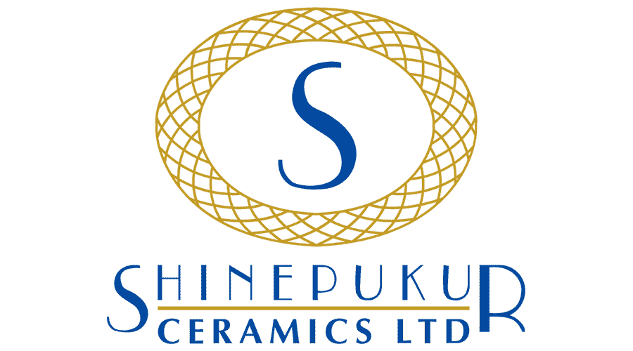

Ms. Nazmun Nahar

Full Time Faculty

Senior Lecturer

Dept. of accounting and Finance

North South University

**Submitted by:**

|  |  |
| --- | --- |
| **Name** | **ID** |
| Ayesha Momtaz Maliha | 2012640030 |
| Noshin Shaiara Teena | 1731121630 |
| Ibrahim Khalil | 2021589030 |
| Nahian Shabab | 2021398630 |
| Maisha Maliha | 2012090030 |
| A F M Ahshanul Haque Shaikh | 1931668030 |
| Mahfuza Khanum Keya | 2021385630 |

**Letter of Transmittal**

December 22, 2022

Nazmun Nahar

Department of Accounting and Finance

North South University

**Subject: Submission of Fin254 report on Shinepukur and Monno**

Dear Ma’am,

With all due respect, we, the Fin254 section 17 students, are now writing a report on financial report of Shinepukur and Monno. The group's members and I have worked hard to make the report as powerful as we possibly could. We want to take this opportunity to thank you very much for helping us with the report and for your support. Without your help, we would not have been able to accomplish our goal. We apologize for any small mistakes we may have made. Mention any alterations or recommendations you would want us to make.

We would be happy to consider any recommendations you may have. We appreciate your cooperation and support during the whole semester. We are eager to hear more from you.

Sincerely,

Mahfuza Khanum Keya ID 2021385630 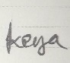

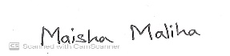Maisha Maliha ID 2012090030

Ibrahim Khalil ID 2021589030 

Noshin Shaira Teena ID 1731121630 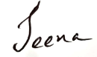

Ayesha Momtaz Maliha ID 2012640030 

Nahian Shabab ID 2021398630 

A F M Ahshanul Haque Shaikh ID 1931668030 

**Abstract:** This research is based on Monno Ceramics and Shinepukur Ceramics, the two most prominent companies in Bangladesh. It is based on information gathered from reliable online sources throughout the previous four years (2018–2021). This report includes all the essential facts about the two businesses, and in the first two sections, we assess the income statements, current ratios, and quick ratios of both businesses on separate Excel sheets. Furthermore, it included enough graphics to help the reader understand the financial data based on cross-sectional analysis and time series analysis. Both companies were analyzed, and this report included some ratios and data from our study materials. The study will conclude by giving the financial status of both companies, their level when compared to one another, and recommendations based on the financial information.

Table of contents

***Introduction…………………................................................................................................................5***

***Company Overview........................................................................................................................5***

***Ratio Analysis***

***Liquidity Ratio ...............................................................................................................................6***

***Activity Management Ratio.........................................................................................................10***

***Debt Ratio .................................................................................................................................. 16***

***Profitability Ratio........................................................................................................................ 20***

***Market Ratio...............................................................................................................................30***

***Recommendation.........................................................................................................................33***

***Conclusion...................................................................................................................................34***

***References...................................................................................................................................35***

***Appendix.....................................................................................................................................36***

**Introduction**

The overall report is based on a ratio analysis of two companies “Monno Ceramics Ltd” and “Shinepukur Ceramics Ltd.” from 2018 to 2021. The entire report focuses on five key metrics: liquidity ratio, financial risk ratio, efficiency ratio, profitability ratio and market ratio. In this report, we have analyzed the metrics of each company to identify which companies are performing better. In addition to ratio analysis, the report also includes a brief description of his two companies and calculations presented in the appendix. After overall analysis of the report, conclusions were drawn for the two companies and recommendations were made for both companies.

Company Overview

**Monno Ceramics Ltd.**

The Monno Group, one of the biggest private corporate conglomerates in Bangladesh, is led by Monno Ceramic Industries Ltd. In 1984, it was created. Harunur Rashid Khan is the founder. Each month, the company produces 15,000 pieces of bone china and 75,000 pieces of porcelain.

Monno Ceramic has earned the "National Export Trophy" for a record 09 (Nine) times from the Government of Bangladesh as recognition for being one of the top exporters of ceramic dinnerware from Bangladesh. The only producer of ceramic dinnerware to obtain such distinction in a record quantity is Monno Ceramic, which is the first to do so in Bangladesh. They sell their goods to a variety of nations, including Poland, Turkey, Japan, Australia, the United Arab Emirates, Brazil, Chile, Egypt, Russia, Romania, Sweden, Norway, Denmark, and Spain, among others.

**Shinepukur Ceramics Ltd.**

An organization named Shinepukur makes ceramic dinnerware. Shinepukur Ceramics was incorporated in 1997 and began producing goods for sale towards the end of 1999. Shinepukur Ceramics Limited (SCL) is a part of the Beximco Group, the largest private sector business conglomerate in Bangladesh. With more than 48,000 employees worldwide on a permanent payroll and more than 300,000 overall, the group manages a diverse range of goods going to and coming from Bangladesh. Two different products are produced by them: porcelain & bone china.

They sell to countries including the USA, Canada, the UK, Germany, France, Italy, Romania, Sweden, Norway, Denmark, Spain, Poland, Turkey, Japan, Australia, the United Arab Emirates, Brazil, India, Chile, Egypt, Russia, and more. According to their annual report for 2017–2028, they have 5,000 million Taka in authorized capital, 966.34 million in paid-up capital, and 24,000 shareholders. The top exporter of ceramic tableware in the nation, Shinepukur Ceramics Ltd. (SCL), has been awarded the "Dun & Bradstreet Corporate Award" in its category. The first and only listed ceramic-tableware producer in the nation to receive this honor from Dun & Bradstreet Rating Agency Bangladesh Limited is Shinepukur Ceramics.

**Liquidity Ratio**

1. **Current Ratio:**

|  |  |  |  |  |
| --- | --- | --- | --- | --- |
| **Company** | **2021** | **2020** | **2019** | **2018** |
| MONNO Ceramics | 1.25 | 1.33 | 1.34 | 1.25 |
| SHINEPUKUR Ceramics | .76 | .76 | .71 | .34 |

**MONNO Ceramics**

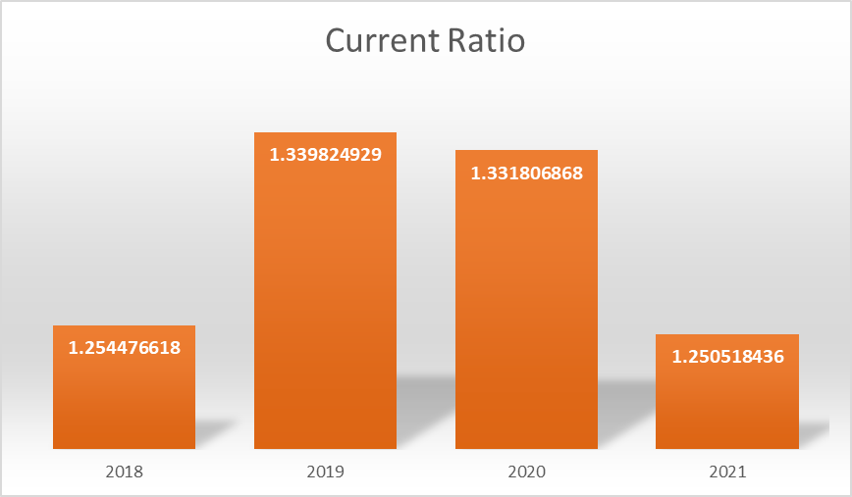

**SHINEPUKUR Ceramics**

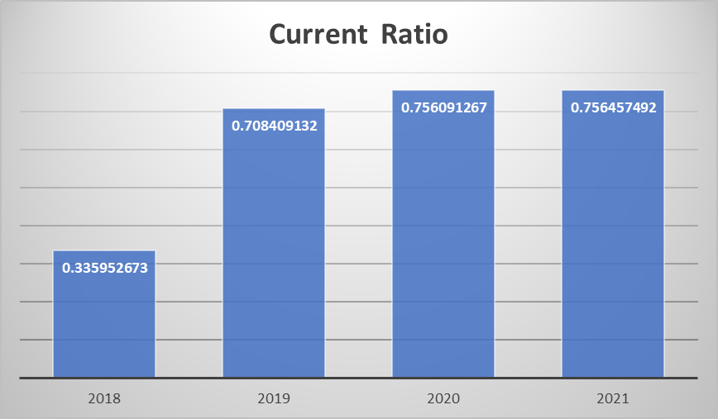

**Interpretation:** For MONNO Ceramics, ratio of 1.25:1 means that for every dollar of current liabilities, they have $1.25 of current asset. Again, for SHINEPUKUR Ceramics, ratio of 0.76:1 means that for every dollar of current liabilities, they have $0.76 of current asset.

**Time Series:** If we compare it from time series perspective, MONNO Ceramic’s current ratio of 2018, 2019,2020,2021’s is respectively 1.25,1.34,1.33,1.25 which show the deterioration situation from previous year. This scenario of the company may cause liquidity issue. Besides, they are not very far from benchmark. They should pay a little bit attention to their short-term asset to back up their short-term liability to reach benchmark.

On the other hand, SHINEPUKUR Ceramic’s current ratio of 2018, 2019,2020,2021’s is respectively 0.76,0.76,0.71,0.34 which show the improving situation from previous year. But this improvement of that particular company is not sufficient enough to back up their short-term obligations with its short-term assets. Though considering previous year they are improving, it is not enough. To solve this problem and reach to the benchmark 2:1, they have to pay attention to their short-term assets. Otherwise, in near future they will face very bad situation in that particular company.

**Cross Sectional:** With a ratio of 1.25:1, MONNO Ceramics has $1.25 in current assets for every dollar in current liabilities which means MONNO Ceramic is trying to back up its short-term obligations with its very short-term asset as it’s come due and close to ideal benchmark 2:1.

Once more, the ratio of 0.76:1 for SHINEPUKUR Ceramics indicates that they have $0.76 in current assets for every $1 in current liabilities which means they are not sufficient enough to back up their short-term obligations with its very short-term liabilities. They have to improve themselves to avoid liquidity issue.

1. **Quick Ratio:**

|  |  |  |  |  |
| --- | --- | --- | --- | --- |
| **Company** | **2021** | **2020** | **2019** | **2018** |
| MONNO Ceramics | 0.75 | 0.80 | 0.87 | 0.71 |
| SHINEPUKUR Ceramics | 0.23 | 0.20 | 0.23 | 0.18 |

**MONNO Ceramics**

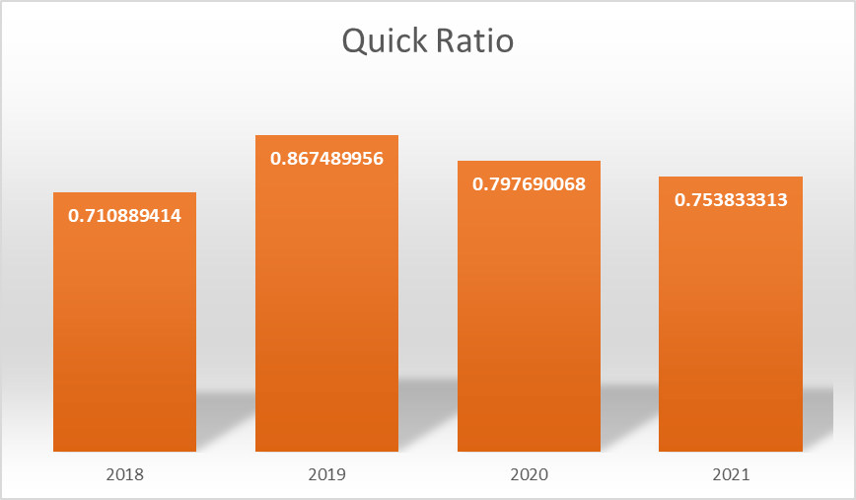

**SHINEPUKUR Ceramics**

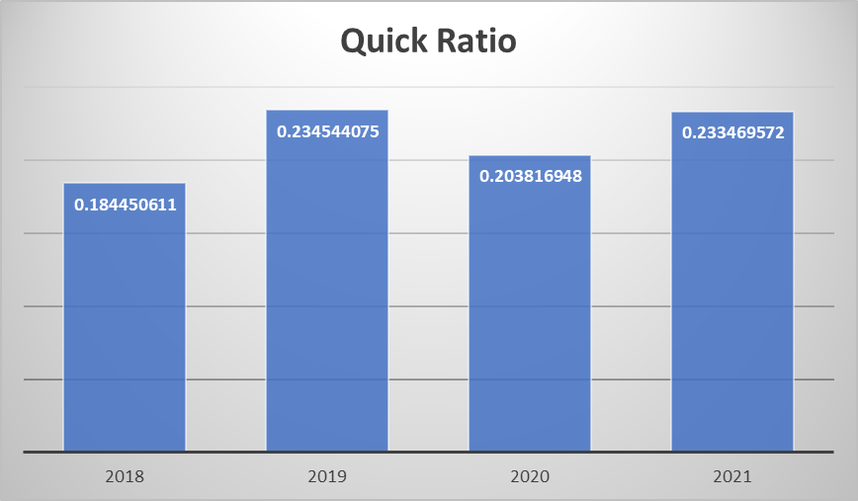

**Interpretation:** To interpret, in 2021 MONNO Ceramic’s current assets except inventories was .75 times if its current liabilities. To put it another way, SHINEPUKUR Ceramic's current assets, excluding inventory, were 0.23 times as great as its current liabilities in 2021.

**Time Series:** For MONNO Ceramics, from 2018, quick ratio of that particular company, we can say for $1 of liability, they have the most liquid portion of current asset is $0.71. Compared to 2019 & 2020 it has increased. Again, in 2021, they decreased. Very high amount of cash, receivables, inventories are not desired. The company is maintaining a good condition in terms of quick ration to back up their very short-term obligations.

For SHINEPUKUR Ceramics, as of 2018, the company's quick ratio tells us that for every $1 in liabilities, their most liquid current asset is only $0.18, which is a very unfavorable sign. In contrast to 2019, 2020, and 2021, it has not increased as anticipated. In terms of quick ratio, they are in a terrible predicament. In order to fulfill their immediate responsibilities, individuals should therefore thoroughly consider their most current assets.

**Cross-sectional:** Except for inventories, MONNO Ceramic's current assets in 2021 were.75 times its current liabilities. MONNO continues to be in fantastic shape. In other words, in 2021, SHINEPUKUR Ceramic's current assets, excluding inventories, were 0.23 times more than its current liabilities. The most recent asset should be managed as quickly as possible.

**Activity Ratio:**

1. **Inventory turnover Ratio:**

|  |  |  |  |  |
| --- | --- | --- | --- | --- |
| **Company** | **2021** | **2020** | **2019** | **2018** |
| MONNO Ceramics | 1.55 | 1.36 | 3.02 | 2.14 |
| SHINEPUKUR Ceramics | 1.33 | 6.95 | 1.38 | 1.58 |

**MONNO Ceramics**

**SHINEPUKUR Ceramics**

**Interpretation:** MONNO Ceramics sold and restocked their inventory 1.55 times in 2021, according to this interpretation. On the other hand, SHINEPUKUR Ceramics increased inventory 1.33 times in 2021 through sales and replenishment.

**Time Series:** MONNO Ceramic’s inventory turnover of 2018,2019,2020,2021’s is respectively 2.14, 3.02, 1.36, 1.55 which indicates fluctuational situation in those particular years. In 2018 & 2019 the inventory turnover is in an efficient manner compare to the 2020 & 2021. 2018 is best among those year because they sold their inventories more frequently than other particular years. The more times indicate more betterment.

The inventory turnover for SHINEPUKUR Ceramic in the years 2018, 2019, 2020, and 2021 was, respectively, 1.58,1.38,6.95, and 1.33, which shows a fluctuating scenario in those specific years. In 2018, 2019, & 2021 they keep their tight proximity, but in 2020 the turnover is 6.95, indicating a highly profitable situation. Additionally, their status worsened in 2021. We consistently anticipate high inventory turnover.

**Cross-sectional:** Compare to MONNO Ceramics, SHINEPUUR Ceramics they are doing almost same except 2020 of SHINEPUKUR. They both should pay attention for better control on their current asset which will impact their profitability and increase their health of business organization.

1. **Receivable turnover:**

|  |  |  |  |  |
| --- | --- | --- | --- | --- |
| **Company** | **2021** | **2020** | **2019** | **2018** |
| MONNO Ceramics | 4.81 | 4.39 | 7.92 | 9.55 |
| SHINEPUKUR Ceramics | 7.47 | 6.74 | 5.62 | 7.71 |

**MONNO Ceramics**

**SHINEPUKUR Ceramics**

**Interpretation:** In 2021, MONNO Ceramics needed to recover their account receivable from consumers 4.81 times as long. Additionally, SHINEPUKUR Ceramics took 7.47 times as long in 2021 to recover its account receivable from consumers.

**Time Series**: If we want to conduct time series comparison for MONNO, from 2018-2021 the receivables turnover has decreased from 9.55-4.81. They should pay attention to their receivable turnover otherwise they may face liquidity crisis. Collecting receivables earlier is good.

If we wish to compare time series for SHINEPUKUR, the receivables turnover fell from 7.71 to 7.47 between 2018 and 2021. Among those year the condition fluctuated. But the condition of fluctuation is close to each other.

**Cross-sectional:** Comparing MONNO to SHINEPUKUR, MONNO is lagging behind. MONNO is not maintaining satisfactory collection at all. They further need to look into their collection because they may be followed lose credit policy which may refer MONOO liquidity crisis. SHINEPUKUR is doing good rather than other particular company

**iii)Fixed Asset Turnover:**

|  |  |  |  |  |
| --- | --- | --- | --- | --- |
| **Company** | **2021** | **2020** | **2019** | **2018** |
| MONNO Ceramics | 0.31 | 0.27 | 0.46 | 0.39 |
| SHINEPUKUR Ceramics | 0.26 | 0.23 | 0.29 | 0.28 |

**MONNO Ceramics**

**SHINEPUKUR Ceramics**

**Interpretation:** For MONNO, this suggests that in 2021, sales will be 0.31 times higher than fixed assets. Additionally, it suggests that SHINEPUKR will be able to generate 0.26 times more revenue in 2021 from sales than from fixed assets.

**Time series:** For MONNO, from 2018,2019,2020,2021 the fixed asset turnovers are 0.31,0.27,0.46,0.39 which indicate they are fluctuated negatively. That means, they are nit utilizing their fixed asset.

For SHINEPUKUR, the fixed asset turnovers for the years 2018, 2019, 2020, and 2021 are 0.28, 0.29, 0.23, and 0.26, respectively, indicating negative fluctuations. That implies that they are not effectively using their fixed asset.

**Cross-sectional:** Compare MONNO to SHINEPUKUR, MONNO is doing good than SHINEPUKUR. If fixed asset turnover rises, that means, they are utilizing their fixed asset efficiently. SHINEPUKUR should pay attention to their fixed asset turnover and utilizing their fixed asset properly than MONNO.

**Debt Ratio:**

1. **Debt Ratio**

|  |  |  |  |  |
| --- | --- | --- | --- | --- |
| **Company** | **2021** | **2020** | **2019** | **2018** |
| MONNO Ceramics | 0.27 | 0.26 | 1.05 | 1.05 |
| SHINEPUKUR Ceramics | 0.28 | 0.30 | 0.32 | 0.32 |

**MONNO Ceramics**

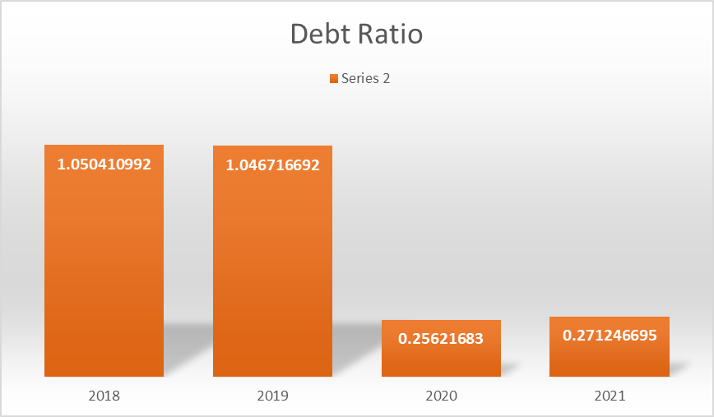

**SHINEPUKUR Ceramics**

**Interpretation:** With $100 in asset in 2021 for MONNO, $27 of that amount comes from debt. With $100 in asset in 2021 for SHINEPUKUR, $28 of that total comes from debt.

**Time series:** For MONNO, from 2018,2019,2020,2021 the debt ratios are 1.05,1.05,0.26,0.27 which indicates very good situation. Debt burden of that particular organization has decreased. The creditors, bond-holders can feel comfort to invest on them.

For SHINEPUKUR, the debt ratios for the years 2018, 2019, 2020, and 2021 are respectively 0.28,0.30,0.32,0.32 which means their debt burden had also declined gradually. They are also in good position in sense of debt ratio. The creditors, bond-holders can also feel comfort to invest on them.

**Cross-sectional:** Compare MONNO to SHINEPUKUR, their debt ratios are close. They both maintain close debt burden in their organizations.

1. **Times Interest Ratio**

|  |  |  |  |  |
| --- | --- | --- | --- | --- |
| **Company** | **2021** | **2020** | **2019** | **2018** |
| MONNO Ceramics | 1.15 | 0.86 | 1.76 | 1.22 |
| SHINEPUKUR Ceramics | 1.73 | 1.15 | 1.73 | 1.57 |

**MONNO Ceramics**

**SHINEPUKUR Ceramics**

**Interpretation:** For MONNO, in 2021 1.15times means the organization is capable of paying its interest expense from its operating income 1.15times. For SHINEPUKUR, this indicates that in 2021, the company will be able to cover its interest costs with 1.73 times as much operating income.

**Time series:** For MONNO, from 2018,2019,2020,2021 the TIE ratios are 1.22,1.76,0.86,1.15 which indicates declining situation. They are not capable of paying its interest expense from its operating income considering previous year.

From 2018,2019,2020,2021 for SHINEPUKUR, the TIE ratios are 1.57,1.73,1.15,1.73 which suggests a better position. Taking into account the prior year, they are able to cover their interest expense from operational income.

**Cross-sectional:** Compare MONNO to SHINEPUKUR, their TIE lower than SHINEPUKUR. Given the prior year, SHINEPUKUR are able to cover their interest costs out of operational income. Their internally generated money can sufficiently backed up their interest expenses than its come due.

**Profitability Ratio**

1. **Gross profit Margin**

|  |  |  |  |  |
| --- | --- | --- | --- | --- |
| **Company** | **2021** | **2020** | **2019** | **2018** |
| MONNO Ceramics | 1.87 | 0.18 | 0.19 | 0.19 |
| SHINEPUKUR Ceramics | 0.16 | 0.15 | 0.22 | 0.23 |

**MONNO Ceramics**

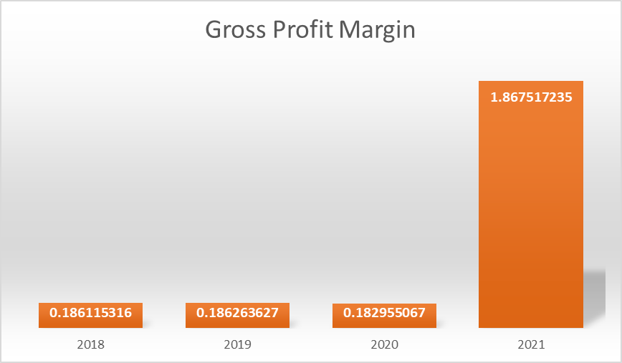

**SHINEPUKUR Ceramics**

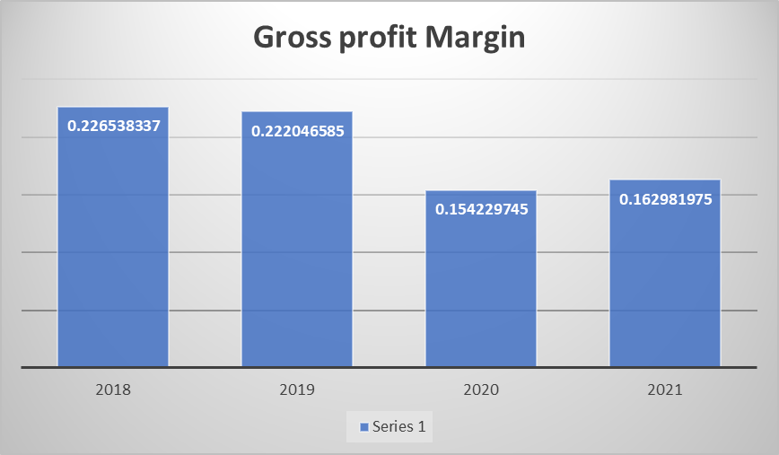

**Interpretation:** For MONNO, in 2021, in $100 of sales, gross profit is $18.5. Again, for SHINEPUKUE Ceramics, in 2021, in $100 of sales, gross profit is $185. in 2021, in $100 of sales, gross profit is $16.

**Time Series**: For MONNO, from 2018-2021 the gross profit margins are 0.19,0.19, .18, 1.87 which indicates almost constant situation. Therefore, to increase gross profit margin, they should look into their direct cost of product, sources, and make the decision effectively.

For SHINEPUKUR, from 2018-2021 the gross profit margins are 0.23, 0.22, 0.15, 0.16 which indicates decreasing situation. Probably from previous year either net sales are in same level or cost of goods sold decreased.

**Cross Sectional:** Compare MONNO to SHINEPUKUR, MONNO is doing good than SHINEPUKUR. Therefore, they to increase gross profit margin, they should look into their direct cost of product, sources, and make the decision effectively.

1. **Operating Profit Margin**

|  |  |  |  |  |
| --- | --- | --- | --- | --- |
| **Company** | **2021** | **2020** | **2019** | **2018** |
| MONNO Ceramics | 0.07 | 0.09 | 0.06 | 0.08 |
| SHINEPUKUR Ceramics | 0.10 | 0.08 | 0.15 | 0.15 |

**MONNO Ceramics**

**SHINEPUKUR Ceramics**

**Interpretation**: In 2021, for every TK100 worth of sale MONNO generated Tk7 operating profit. In 2021, for every Tk.100 worth of sale SHINEPUKUR generated Tk10 operating profit.

**Time Series:** For MONNO, in 2018, for every Tk.100 worth of sale MONNO generated Tk.8 operating profit. The operating profit margin decreased from the previous years. In terms of the previous year the performance, the firm performance drives down in 2019 they have 6% operating profit it increased to 9%% in 2022. Overall, the performance was getting worse.

In 2018, for every Tk.100 worth of sale SHINPUKUR generated Tk.15 operating profit. The operating profit margin remain same at 2019. In terms of those years the performance, the firm performance was highest in 2019 & 2019 when they had 15% operating profit and it decreased to 8% and 10% respective to year 2020 & 2021

**Cross-sectional:** Compare MONNO to SHINEPUKUR, SHINEPUKUR is doing good than MONNO. MONNO’s operating profit is decreasing probably they couldn’t sale off or they are not looking into their expense section, may be their cost is increased from the previous year.

1. **Net Profit Margin**

|  |  |  |  |  |
| --- | --- | --- | --- | --- |
| **Company** | **2021** | **2020** | **2019** | **2018** |
| MONNO Ceramics | 0.05 | 0.03 | 0.07 | 0.06 |
| SHINEPUKUR Ceramics | 0.03 | 0.03 | 0.04 | 0.04 |

**MONNO Ceramics**

**SHINEPUKUR Ceramics**

**Interpretation:** The net profit margin measures the percentage of earnings available for shareholders remaining from its sales. For each Taka of sales, MONNO’s net profit is TK.5 in 2021. For each Taka of sales, SHINEPUKUR’s net profit is TK.3 in 2021.

**Time Series**: For every Tk.100 in sales in 2021, MONNO made a net profit of Tk.5. From the prior years, the net profit margin varied. Whereas the company's performance was 6% in 2018 but just 3% in 2020, it is constantly declining. The overall level of performance was fluctuating.

In 2021, SHINEPUKUR made a net profit of Tk. 3 for every Tk. 100 in sales. In comparison to the results of the prior year, the net profit margin has consistently been low. In comparison to the prior year, the company's performance is consistently declining, with a 4% net profit in 2020 and a 3% decrease in 2021.

**Cross-sectional:** Compare MONNO to SHINEPUKUR, SHINEPUKUR is doing bad than MONNO for the particular four years. That means SHINEPUKUR may be actually decrease their sales or net income. Probably they couldn’t reduce their expenses. They should pay attention over this.

1. **ROE (Return on Equity)**

|  |  |  |  |  |
| --- | --- | --- | --- | --- |
| **Company** | **2021** | **2020** | **2019** | **2018** |
| MONNO Ceramics | 0.01 | 0.01 | 0.02 | 0.02 |
| SHINEPUKUR Ceramics | 0.01 | 0.00 | 0.01 | 0.04 |

**MONNO Ceramics**

**SHINEPUKUR Ceramics**

**Interpretation:** The return on equity measures the return earned on the common stockholder’s investment in the firm. Generally, the owners are better off the higher is this return. ROE 1% implies that for each Tk. 100 worth of shareholder's investment, MONNO earned Tk.1 worth of profit in 2021. ROE 1% implies that for each Tk. 100 worth of shareholder's investment, SHINEPUKUR earned Tk.1 worth of profit in 2021.

**Time series:** For MONNO, from 2018-2021, they are decreasing from 2% to 1%. It means they are not utilizing owner’s investment in the business in generating net income or profit.

For SHINEPUKUR, from 2018-2021, they are decreasing from 4% to 1%. It means they are not utilizing owner’s investment in the business in generating net income or profit.

**Cross-sectional:** Compare MONNO to SHINEPUKUR, SHINEPUKUR is doing bad than MONNO for the particular four years. Whenever stockholders putting their money into a business, seeing these situations they will feel demotivated. So, they both should pay attention over it.

1. **ROA (Return on Asset)**

|  |  |  |  |  |
| --- | --- | --- | --- | --- |
| **Company** | **2021** | **2020** | **2019** | **2018** |
| MONNO Ceramics | 0.01 | 0.01 | 0.02 | 0.02 |
| SHINEPUKUR Ceramics | 0.01 | 0.00 | 0.01 | 0.01 |

**MONNO Ceramics**

**SHINEPUKUR Ceramics**

**Interpretation:** The return on assets often called the return on investment (ROI), measures the overall efficiency of management in generating profits with its available assets. The higher the firm’s return on total assets, the better is the company’s performance. ROA 1% in 2021 implies that for each Tk. 100 worth of asset investment, MONNO generated Tk.1 worth of profit from it in that year. ROA 1% in 2021 implies that for each Tk. 100 worth of asset investment, SHINEPUKUR generated Tk.1 worth of profit from it in that year.

**Time series:** ROA of 1% indicates that for every Tk. 100 invested in assets, MONNO made Tk. 1 in profit. return on assets totals from 2018 to 2021, the ratio dropped from 2% to 1%. As a result, we may say that the performance kept becoming worse.

From 2018 to 2021, they will drop from 2% to 1% for SHINEPUKUR. It denotes that they are not making use of the asset in the company to increase net profit.

**Cross-sectional:** When MONNO and SHINEPUKUR are compared, SHINEPUKUR has performed worse than MONNO over the past four years. When shareholders invest money in a company, they are aware of it. Therefore, they should both pay attention to it.

1. **EPS (Earnings Per Share)**

|  |  |  |  |  |
| --- | --- | --- | --- | --- |
| **Company** | **2021** | **2020** | **2019** | **2018** |
| MONNO Ceramics | 0.90 | 0.50 | 2.02 | 2.11 |
| SHINEPUKUR Ceramics | 0.32 | 0.21 | 0.43 | 0.42 |

**MONNO Ceramics**

**SHINEPUKUR Ceramics**

**Interpretation:** Earnings per share (EPS) is a commonly used metric to determine how much net profit is made available for outstanding common stock. MONNO provides its present shareholders with Tk. 90 in earnings for every share, according to its earnings per share of 90.

According to earnings per share 32, SHINEPUKUR provides its present shareholders with 32 Tk in earnings for every share they own.

**Time series:** In contrast to past years, MONNO's earnings per share were low in 2020. Due to the corporation issuing additional share capital in this time period that year, earnings per share decreased significantly from 2018 to 2021, as seen by the numbers 2.11, 2.02, 0.50, and 0.90. Compared to other years, they did well in 2018.

Earnings per share of Tk. 32 indicate that each share is worth Tk. 32 to the company's present owners. In that year, MONNO's owners received substantial earnings per share of Tk.32 allocated to them. It showed that the earnings per share for the shareholders had increased. From 2018 to 2021, there is a considerable decline in earnings per share.

**Cross sectional:** Since MONNO's overall earnings per share are significantly higher than SHINEUKUR's, its investors will benefit from a higher share price for the company. SHINEPUKUR's earnings per share are insufficient to entice shareholders to invest in the business.

**Market Ratio:**

1. **P/E Ratio**

|  |  |  |  |  |
| --- | --- | --- | --- | --- |
| **Company** | **2021** | **2020** | **2019** | **2018** |
| MONNO Ceramics | 120.00 | 194.00 | 58.42 | 64.93 |
| SHINEPUKUR Ceramics | 121.88 | 233.33 | 130.23 | 126.19 |

**MONNO Ceramics**

**SHINEPUKUR Ceramics**

**Interpretation:** For MOONO, in 2021 investors are willing to pay per dollar of income for each share $120. For SHINEPUKUR, in 2021 investors are willing to pay per dollar of income for each share $121.88.

**Time series:** For MONNO, from 2018-2021 the P/E ratios are respectively 64.93, 58.42,194,120 which indicates fluctuation negatively. In 2020, the company was done good rather than 2021.

For SHINEPUKUR Ceramics, from 2018-2021 the P/E ratios are respectively 126.19,130.23,233.33,121.88 which indicates decreasing situation. In 2020, they also did good rather than other particular year.

**Cross sectional:** Compare MONNO to SHINPUKUR, SHINEPUKUR did good than the other. Negative fluctuation reflects the negative confidence of the investors in the market over the organization.

1. **M/B Ratio**

|  |  |  |  |  |
| --- | --- | --- | --- | --- |
| **Company** | **2021** | **2020** | **2019** | **2018** |
| MONNO Ceramics | 1.26 | 1.15 | 1.42 | 1.67 |
| SHINEPUKUR Ceramics | 0.87 | 1.12 | 1.24 | 1.20 |

**MONNO Ceramics**

**SHINEPUKUR Ceramics**

**Interpretation**: The market/book ratio of 1.26 times for MONNO in 2021 indicates that the market price of MONNO's share is 1.26 times more than the book value. According to the market/book ratio for SHINEPUKUR in 2021, the market price of a share is 0.87 times more than the book value.

**Time series:** For MONNO, in 2021, the market/book ratio 1.26times implies that the market price of MONNO’s share is 1.26times higher than the book value. Based on the previous year performance, the firm's performance figure is decreasing and in 2020 it was lowest with 1.15. While the highest performance being 1.67 times in 2018, we can conclude that the performance was continually worsening since the market price per share is decreasing every year.

The market/book ratio of 0.87 times for SHINEPUKUR in 2021 suggests that the market price of SHINEPUKUR’s share is 0.87 times greater than the book value. The firm's performance statistic is declining based on the previous year's performance, and in 2021 it reached its lowest point with 0.87. The maximum performance was 1.24 times in 2019, however as the market price per share is declining every year, we can infer that the performance was continuously deteriorating.

**Cross sectional:** Compare MONNO to SHINPUKUR, SHINEPUKUR did bad rather than MONNO. Investors are actually regarding that organization as a potential one. They expect optimism from organization that the earnings will increase in future.

**RECOMMENDATION:**

After analyzing two company there are a few suggestions and based on those recommendations investor can select the best choice.

**Liquidity ratios:** Shine pukur ceramics have extremely low liquidity ratios, whereas Monno ceramics have greatly high liquidity ratios. A liquidity ratio that's either as well high or too low isn't satisfactory. As a result, they ought to both make judicious utilize of their current assets and keep up an adequate current asset base to cover their current liabilities when they develop.

**Activity ratios**: Shinepukur ceramics essential focus ought to be on asset management. They ought to increment their sales and collect receivables more rapidly. Shinepukur and monno ceramics ought to both short their payment terms.

**Profitability ratios:** Shinepukur ceramics have some low profitability ratios when we compared to Monno ceramics. They ought to take critical steps to generate sufficient revenue from operations, which is able result in expanded benefit.

**Debt management ratios:** shinepukur ceramics financed its resources through a huge amount of debt, which they ought to use to produce a high level of EBIT by appropriately utilizing it to cover yearly interest installments.

**Market ratios:** Shinepukur and monno ceramics both illustrated a descending trend in their market book ratios, which may show a negative situation. As a result, they ought to actualize procedures to progress their money related execution in arrange for financial specialists to consider them as potential investments.

**CONCLUSION:** After conducting an intensive analysis of both Shinepukur and Monno ceramics, we have come to a few conclusions almost their generally execution. Ratio analysis and graphical introduction uncover that the Shinepukur and Monno ceramics ratios are marketly distinctive. Monno ceramics growth,asset administration capability, and profitability rate are all greatly high, which is able effectively draw in any financial specialist. Comparing each ratio over the final four a long time illustrates unequivocally that Monno ceramics have imperfections and may change, but they keep up a much stronger market position than Shinepukur.

**Reference**

# Reference

Annual Reports - Shinepukur Ceramics Ltd. [https://www.shinepukur.com/annual-reports. Accessed 28 Dec. 2022](https://www.shinepukur.com/annual-reports.%20Accessed%2028%20Dec.%202022).

Investors – Monno Group. <http://monno-group.com/investors/>. Accessed 28 Dec. 2022

“SPCERAMICS | Shinepukur Ceramics Ltd. Stock Overview (Dhaka Stock Exchange).” Barron’s, <https://www.barrons.com/market-data/stocks/spceramics?countrycode=bd> Accessed 28 Dec. 2022.

“MONNOCERA | Monno Ceramic Industries Ltd. Stock Overview (Dhaka Stock Exchange).” Barron’s, <https://www.barrons.com/market-data/stocks/monnocera?countrycode=bd> Accessed 28 Dec. 2022.

**Appendix**

